

**NCSE Special Classes in Mainstream Schools**

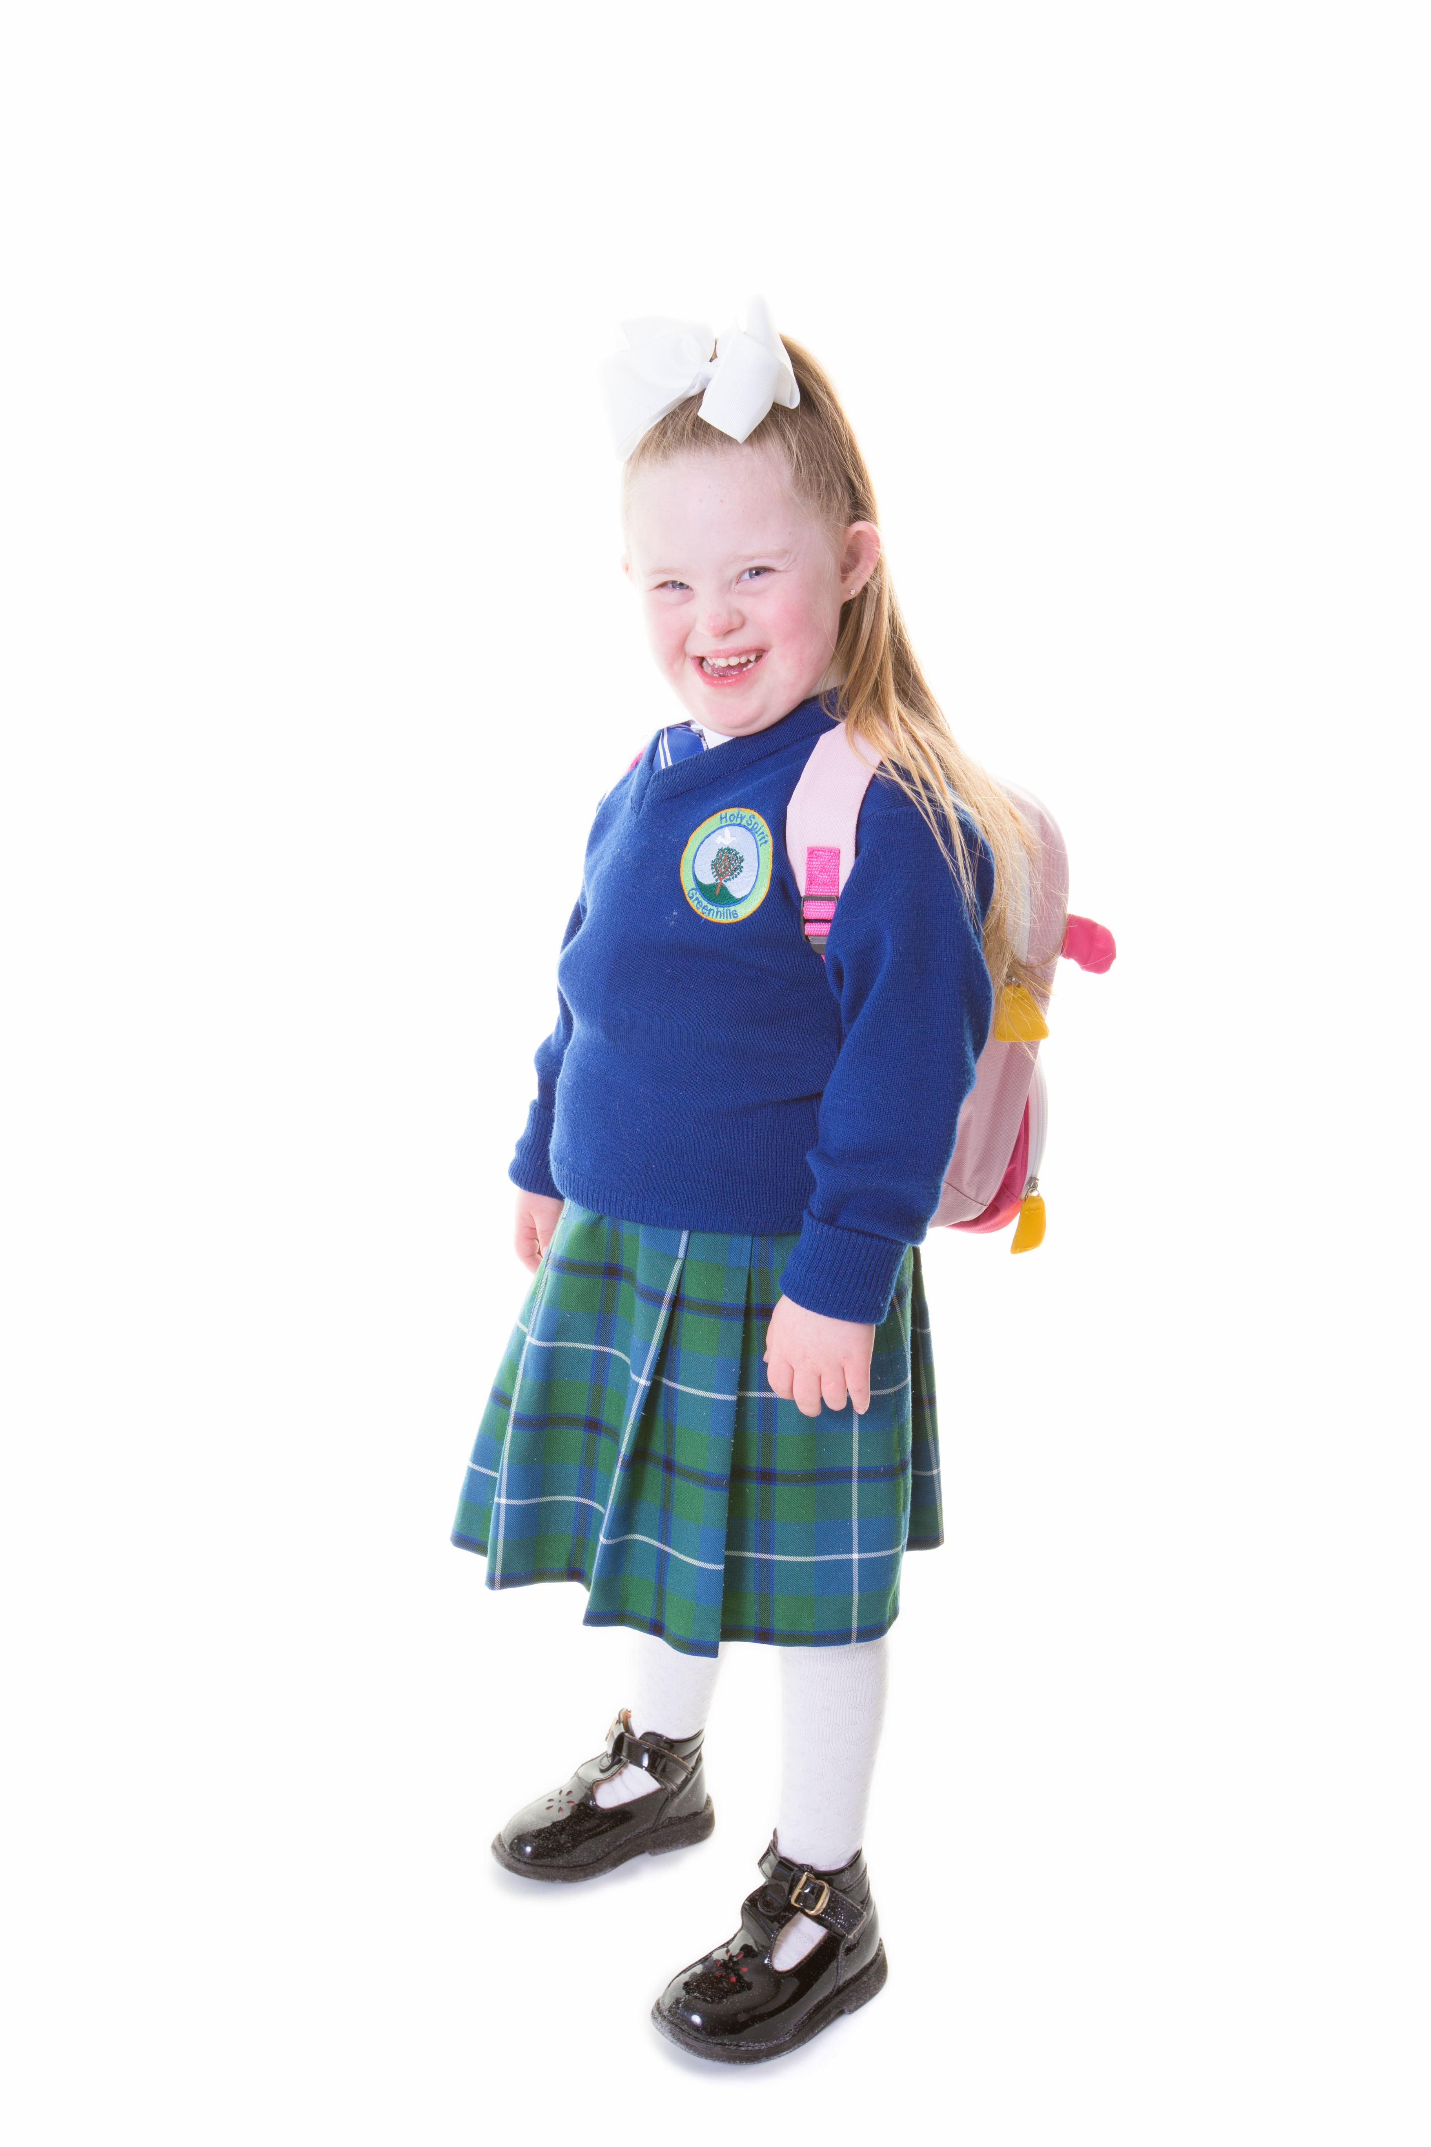

**DSI Report**

**May 21st 2025**

**Introduction**

The NCSE publish the list of Special Classes in Mainstream Schools, Primary & Post Primary. This list is updated over the course of the school year as new classes are established. Our original report was compiled based on the list published on September 11th 2024.

This report is an updated overview of the Special Classes (by County) in Mainstream Primary and Post Primary Schools for the 2025-2026 School Year. The figures contained in the report are those obtained from the NCSE updated list on April 23rd 2025.

**Overview of Class Types**

* Autism / Autistic Spectrum
* ASD Early Intervention
* Mild General Learning Disability
* Moderate General Learning Disability
* Severe / Profound General Learning Disability
* Specific Speech & Language
* Hearing Impairment
* Early Intervention Hearing Impairment
* Visual Impairment
* Multiple Disabilities
* Specific Learning Disability
* Emotional & Behavioural
* Emotional Disturbance
* Other

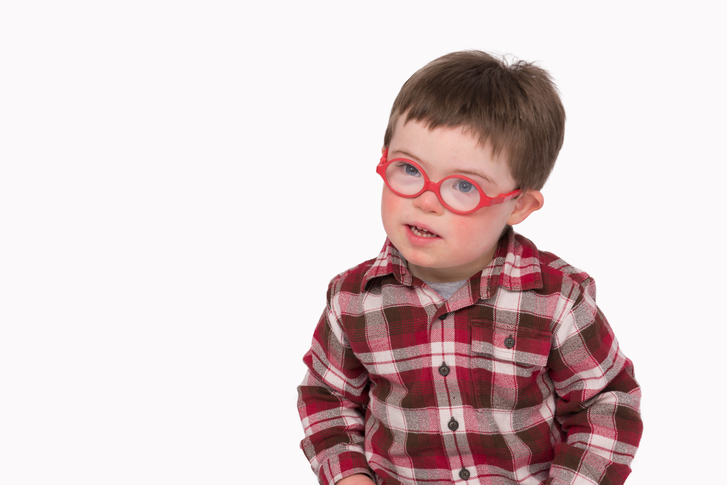

**Overview of Special Classes by County & School Setting as on April 23rd 2025**

**(***NCSE numbers* [*www.ncse.ie*](http://www.ncse.ie)**)**

|  |  |  |  |  |
| --- | --- | --- | --- | --- |
| **Carlow** | | | | |
| **Class Type** | **Primary**  **April 2025** | **Change from September 2024** | **Post Primary**  **April**  **2025** | **Change from September 2024** |
| **Autism / Autistic Spectrum** | 40 | +6 | 19 | +1 |
| **ASD Early Intervention** | 5 | N/C |  |  |
| **Mild General Learning Disability** |  |  |  |  |
| **Moderate General Learning Disability** | 1 | N/C | 1 | N/C |
| **Severe / Profound General Learning Disability** |  |  |  |  |
| **Specific Speech & Language** |  |  |  |  |
| **Hearing Impairment** |  |  |  |  |
| **Early Intervention Hearing Impairment** |  |  |  |  |
| **Visual Impairment** |  |  |  |  |
| **Multiple Disabilities** |  |  |  |  |
| **Specific Learning Disability** |  |  |  |  |
| **Emotional & Behavioural** |  |  |  |  |
| **Emotional Disturbance** |  |  |  |  |
| **Other** |  |  |  |  |
|  | **Total Classes** |  | **Total Classes** |  |
| **46** | **+6** | **20** | **+1** |

|  |  |  |  |  |
| --- | --- | --- | --- | --- |
| **Cavan** | | | | |
| **Class Type** | **Primary**  **April 2025** | **Change from September 2024** | **Post Primary**  **April**  **2025** | **Change from September 2024** |
| **Autism / Autistic Spectrum** | 42 | +6 | 12 | +2 |
| **ASD Early Intervention** | 4 | N/C |  |  |
| **Mild General Learning Disability** | 2 | N/C |  |  |
| **Moderate General Learning Disability** | 1 | N/C | 2 | N/C |
| **Severe / Profound General Learning Disability** |  |  |  |  |
| **Specific Speech & Language** | 2 | N/C |  |  |
| **Hearing Impairment** | 1 | N/C | 2 | + 1 |
| **Early Intervention Hearing Impairment** |  |  |  |  |
| **Visual Impairment** |  |  |  |  |
| **Multiple Disabilities** |  |  |  |  |
| **Specific Learning Disability** |  |  |  |  |
| **Emotional & Behavioural** |  |  |  |  |
| **Emotional Disturbance** |  |  |  |  |
| **Other** |  |  |  |  |
|  | Total Classes |  | Total Classes |  |
| **52** | **+6** | **16** | **+2** |

|  |  |  |  |  |
| --- | --- | --- | --- | --- |
| **Clare** | | | | |
| **Class Type** | **Primary**  **April 2025** | **Change from September 2024** | **Post Primary**  **April**  **2025** | **Change from September 2024** |
| **Autism / Autistic Spectrum** | 49 | +3 | 23 | + 4 |
| **ASD Early Intervention** | 3 | N/C |  |  |
| **Mild General Learning Disability** |  |  | 2 | N/C |
| **Moderate General Learning Disability** |  |  |  |  |
| **Severe / Profound General Learning Disability** |  |  |  |  |
| **Specific Speech & Language** | 2 | N/C |  |  |
| **Hearing Impairment** |  |  |  |  |
| **Early Intervention Hearing Impairment** |  |  |  |  |
| **Visual Impairment** |  |  |  |  |
| **Multiple Disabilities** | 2 | N/C |  |  |
| **Specific Learning Disability** | 2 | N/C |  |  |
| **Emotional & Behavioural** |  |  |  |  |
| **Emotional Disturbance** |  |  |  |  |
| **Other** |  |  |  |  |
|  | **Total Classes** |  | **Total Classes** |  |
| **58** | **+ 3** | **25** | **+4** |

|  |  |  |  |  |
| --- | --- | --- | --- | --- |
| **Cork** | | | | |
| **Class Type** | **Primary**  **April 2025** | **Change from September 2024** | **Post Primary**  **April**  **2025** | **Change from September 2024** |
| **Autism / Autistic Spectrum** | 374 | + 31 | 167 | +19 |
| **ASD Early Intervention** | 22 | N/C |  |  |
| **Mild General Learning Disability** | 1 | N/C | 2 | N/C |
| **Moderate General Learning Disability** | 8 | N/C | 8 | N/C |
| **Severe / Profound General Learning Disability** | 1 | N/C |  |  |
| **Specific Speech & Language** | 8 | N/C |  |  |
| **Hearing Impairment** | 5 | N/C | 4 | N/C |
| **Early Intervention Hearing Impairment** | 1 | N/C |  |  |
| **Visual Impairment** |  |  |  |  |
| **Multiple Disabilities** | 6 | N/C | 6 | N/C |
| **Specific Learning Disability** |  |  |  |  |
| **Emotional & Behavioural** |  |  |  |  |
| **Emotional Disturbance** |  |  |  |  |
| **Other** |  |  |  |  |
|  | **Total Classes** |  | **Total Classes** |  |
| **426** | **+ 31** | **187** | **+ 19** |

|  |  |  |  |  |
| --- | --- | --- | --- | --- |
| **Donegal** | | | | |
| **Class Type** | **Primary**  **April 2025** | **Change from September 2024** | **Post Primary**  **April**  **2025** | **Change from September 2024** |
| **Autism / Autistic Spectrum** | 68 | + 5 | 42 | N/C |
| **ASD Early Intervention** | 4 | N/C |  |  |
| **Mild General Learning Disability** |  |  | 3 | N/C |
| **Moderate General Learning Disability** | 1 | N/C | 1 | N/C |
| **Severe / Profound General Learning Disability** | 2 | N/C |  |  |
| **Specific Speech & Language** | 4 | N/C |  |  |
| **Hearing Impairment** |  |  |  |  |
| **Early Intervention Hearing Impairment** |  |  |  |  |
| **Visual Impairment** |  |  |  |  |
| **Multiple Disabilities** | 3 | N/C | 4 | N/C |
| **Specific Learning Disability** |  |  |  |  |
| **Emotional & Behavioural** |  |  |  |  |
| **Emotional Disturbance** |  |  |  |  |
| **Other** |  |  |  |  |
|  | **Total Classes** |  | **Total Classes** |  |
| **82** | **+5** | **50** | **N/C** |

|  |  |  |  |  |
| --- | --- | --- | --- | --- |
| **Dublin** | | | | |
| **Class Type** | **Primary**  **April 2025** | **Change from September 2024** | **Post Primary**  **April**  **2025** | **Change from September 2024** |
| **Autism / Autistic Spectrum** | 484 | + 83 | 156 | + 18 |
| **ASD Early Intervention** | 20 | +1 |  |  |
| **Mild General Learning Disability** | 9 | -2 |  |  |
| **Moderate General Learning Disability** | 3 | +1 | 6 | N/C |
| **Severe / Profound General Learning Disability** | 1 | + 1 |  |  |
| **Specific Speech & Language** | 11 | N/C |  |  |
| **Hearing Impairment** |  |  |  |  |
| **Early Intervention Hearing Impairment** |  |  |  |  |
| **Visual Impairment** |  |  | 2 | N/C |
| **Multiple Disabilities** |  |  |  |  |
| **Specific Learning Disability** | 8 | N/C |  |  |
| **Emotional & Behavioural** |  | -2 |  |  |
| **Emotional Disturbance** | 1 | +1 | 1 | +1 |
| **Other** |  |  | 1 |  |
|  | **Total Classes** |  | **Total Classes** |  |
| **537** | **+83** | **166** | **+ 19** |

|  |  |  |  |  |
| --- | --- | --- | --- | --- |
| **Galway** | | | | |
| **Class Type** | **Primary**  **April 2025** | **Change from September 2024** | **Post Primary**  **April**  **2025** | **Change from September 2024** |
| **Autism / Autistic Spectrum** | 93 | +10 | 60 | **+4** |
| **ASD Early Intervention** | 4 | +1 |  |  |
| **Mild General Learning Disability** | 2 | N/C |  |  |
| **Moderate General Learning Disability** | 4 | N/C | 9 | **N/C** |
| **Severe / Profound General Learning Disability** | 1 | N/C |  |  |
| **Specific Speech & Language** | 4 | -2 |  |  |
| **Hearing Impairment** | 2 | N/C | 1 | N/C |
| **Early Intervention Hearing Impairment** |  |  |  |  |
| **Visual Impairment** |  |  |  |  |
| **Multiple Disabilities** |  | -2 |  |  |
| **Specific Learning Disability** | 1 | +1 |  |  |
| **Emotional & Behavioural** |  |  |  |  |
| **Emotional Disturbance** |  |  |  |  |
| **Other** |  |  |  |  |
|  | **Total Classes** |  | **Total Classes** |  |
| **111** | **+ 8** | **70** | **+ 4** |

|  |  |  |  |  |
| --- | --- | --- | --- | --- |
| **Kerry** | | | | |
| **Class Type** | **Primary**  **April 2025** | **Change from September 2024** | **Post Primary**  **April**  **2025** | **Change from September 2024** |
| **Autism / Autistic Spectrum** | 57 | +8 | 38 | +9 |
| **ASD Early Intervention** | 2 | N/C |  |  |
| **Mild General Learning Disability** | 2 | N/C |  |  |
| **Moderate General Learning Disability** | 3 | +2 | 1 | N/C |
| **Severe / Profound General Learning Disability** |  |  |  |  |
| **Specific Speech & Language** | 2 | N/C |  |  |
| **Hearing Impairment** | 1 | -1 |  |  |
| **Early Intervention Hearing Impairment** |  |  |  |  |
| **Visual Impairment** |  |  |  |  |
| **Multiple Disabilities** | 4 | N/C | 1 | N/C |
| **Specific Learning Disability** | 1 | N/C |  |  |
| **Emotional & Behavioural** |  |  |  |  |
| **Emotional Disturbance** | 2 | N/C | 2 | N/C |
| **Other** |  |  |  |  |
|  | **Total Classes** |  | **Total Classes** |  |
| **74** | **+9** | **42** | **+9** |

|  |  |  |  |  |
| --- | --- | --- | --- | --- |
| **Kildare** | | | | |
| **Class Type** | **Primary**  **April 2025** | **Change from September 2024** | **Post Primary**  **April**  **2025** | **Change from September 2024** |
| **Autism / Autistic Spectrum** | 98 | +12 | 36 | +3 |
| **ASD Early Intervention** | 5 | N/C |  |  |
| **Mild General Learning Disability** | 1 | N/C |  | -2 |
| **Moderate General Learning Disability** | 2 | N/C | 2 | +2 |
| **Severe / Profound General Learning Disability** | 2 | N/C |  |  |
| **Specific Speech & Language** |  |  |  |  |
| **Hearing Impairment** |  |  |  |  |
| **Early Intervention Hearing Impairment** |  |  |  |  |
| **Visual Impairment** |  |  |  |  |
| **Multiple Disabilities** |  |  |  |  |
| **Specific Learning Disability** |  |  |  |  |
| **Emotional & Behavioural** |  |  |  |  |
| **Emotional Disturbance** |  |  |  |  |
| **Other** |  |  |  |  |
|  | **Total Classes** |  | **Total Classes** |  |
| **108** | **+12** | **38** | **+3** |

|  |  |  |  |  |
| --- | --- | --- | --- | --- |
| **Kilkenny** | | | | |
| **Class Type** | **Primary**  **April 2025** | **Change from September 2024** | **Post Primary**  **April**  **2025** | **Change from September 2024** |
| **Autism / Autistic Spectrum** | 40 | +6 | 20 | +1 |
| **ASD Early Intervention** | 3 | N/C |  |  |
| **Mild General Learning Disability** |  |  |  |  |
| **Moderate General Learning Disability** | 1 | N/C | 4 | +1 |
| **Severe / Profound General Learning Disability** |  |  |  |  |
| **Specific Speech & Language** | 3 | +1 |  |  |
| **Hearing Impairment** |  |  |  |  |
| **Early Intervention Hearing Impairment** |  |  |  |  |
| **Visual Impairment** |  |  |  |  |
| **Multiple Disabilities** |  |  |  |  |
| **Specific Learning Disability** |  |  |  |  |
| **Emotional & Behavioural** |  |  |  |  |
| **Emotional Disturbance** |  |  |  |  |
| **Other** |  |  |  |  |
|  | **Total Classes** |  | **Total Classes** |  |
| **47** | **+7** | **24** | **+2** |

|  |  |  |  |  |
| --- | --- | --- | --- | --- |
| **Laois** | | | | |
| **Class Type** | **Primary**  **April 2025** | **Change from September 2024** | **Post Primary**  **April**  **2025** | **Change from September 2024** |
| **Autism / Autistic Spectrum** | 58 | +6 | 23 | +2 |
| **ASD Early Intervention** | 5 | --1 |  |  |
| **Mild General Learning Disability** |  |  |  |  |
| **Moderate General Learning Disability** |  |  |  |  |
| **Severe / Profound General Learning Disability** |  |  |  |  |
| **Specific Speech & Language** | 1 | N/C |  |  |
| **Hearing Impairment** |  |  | 1 | N/C |
| **Early Intervention Hearing Impairment** |  |  |  |  |
| **Visual Impairment** |  |  |  |  |
| **Multiple Disabilities** |  |  |  |  |
| **Specific Learning Disability** |  |  |  |  |
| **Emotional & Behavioural** |  |  |  |  |
| **Emotional Disturbance** |  |  |  |  |
| **Other** |  |  |  |  |
|  | **Total Classes** |  | **Total Classes** |  |
| **64** | **+5** | **24** | **+2** |

|  |  |  |  |  |
| --- | --- | --- | --- | --- |
| **Leitrim** | | | | |
| **Class Type** | **Primary**  **April 2025** | **Change from September 2024** | **Post Primary**  **April**  **2025** | **Change from September 2024** |
| **Autism / Autistic Spectrum** | 18 | +3 | 12 | N/C |
| **ASD Early Intervention** | 1 | N/C |  |  |
| **Mild General Learning Disability** |  |  |  |  |
| **Moderate General Learning Disability** |  |  | 3 | N/C |
| **Severe / Profound General Learning Disability** |  |  |  |  |
| **Specific Speech & Language** |  |  |  |  |
| **Hearing Impairment** |  |  |  |  |
| **Early Intervention Hearing Impairment** |  |  |  |  |
| **Visual Impairment** |  |  |  |  |
| **Multiple Disabilities** |  |  |  |  |
| **Specific Learning Disability** |  |  |  |  |
| **Emotional & Behavioural** |  |  |  |  |
| **Emotional Disturbance** |  |  |  |  |
| **Other** |  |  |  |  |
|  | **Total Classes** |  | **Total Classes** |  |
| **19** | **+3** | **15** | **N/C** |

|  |  |  |  |  |
| --- | --- | --- | --- | --- |
| **Limerick** | | | | |
| **Class Type** | **Primary**  **April 2025** | **Change from September 2024** | **Post Primary**  **April**  **2025** | **Change from September 2024** |
| **Autism / Autistic Spectrum** | 104 | +15 | 45 | +3 |
| **ASD Early Intervention** | 6 | +2 |  |  |
| **Mild General Learning Disability** | 2 | N/C | 1 | N/C |
| **Moderate General Learning Disability** | 1 | N/C |  |  |
| **Severe / Profound General Learning Disability** |  |  |  |  |
| **Specific Speech & Language** | 4 | N/C |  |  |
| **Hearing Impairment** | 1 | N/C | 1 | N/C |
| **Early Intervention Hearing Impairment** |  |  |  |  |
| **Visual Impairment** |  |  |  |  |
| **Multiple Disabilities** |  |  |  |  |
| **Specific Learning Disability** |  |  |  |  |
| **Emotional & Behavioural** |  |  |  |  |
| **Emotional Disturbance** | 1 | N/C |  |  |
| **Other** |  |  |  |  |
|  | **Total Classes** |  | **Total Classes** |  |
| **119** | **+17** | **47** | **+3** |

|  |  |  |  |  |
| --- | --- | --- | --- | --- |
| **Longford** | | | | |
| **Class Type** | **Primary**  **April 2025** | **Change from**  **September 2024** | **Post Primary**  **April**  **2025** | **Change from September 2024** |
| **Autism / Autistic Spectrum** | 27 | N/C | 17 | +1 |
| **ASD Early Intervention** | 3 | N/C |  |  |
| **Mild General Learning Disability** |  |  | 1 | N/C |
| **Moderate General Learning Disability** |  |  |  |  |
| **Severe / Profound General Learning Disability** |  |  |  |  |
| **Specific Speech & Language** |  |  |  |  |
| **Hearing Impairment** |  |  |  |  |
| **Early Intervention Hearing Impairment** |  |  |  |  |
| **Visual Impairment** |  |  |  |  |
| **Multiple Disabilities** |  |  |  |  |
| **Specific Learning Disability** |  |  |  |  |
| **Emotional & Behavioural** |  |  |  |  |
| **Emotional Disturbance** |  |  |  |  |
| **Other** |  |  |  |  |
|  | **Total Classes** |  | **Total Classes** |  |
| **30** | **N/C** | **18** | **+1** |

|  |  |  |  |  |
| --- | --- | --- | --- | --- |
| **Louth** | | | | |
| **Class Type** | **Primary**  **April 2025** | **Change from September 2024** | **Post Primary**  **April**  **2025** | **Change from September 2024** |
| **Autism / Autistic Spectrum** | 73 | +13 | 27 | +4 |
| **ASD Early Intervention** | 9 | N/C |  |  |
| **Mild General Learning Disability** |  |  |  |  |
| **Moderate General Learning Disability** |  |  |  |  |
| **Severe / Profound General Learning Disability** | 1 | N/C |  |  |
| **Specific Speech & Language** | 2 | N/C |  |  |
| **Hearing Impairment** |  |  |  |  |
| **Early Intervention Hearing Impairment** |  |  |  |  |
| **Visual Impairment** |  |  |  |  |
| **Multiple Disabilities** | 1 | N/C |  |  |
| **Specific Learning Disability** | 1 | N/C |  |  |
| **Emotional & Behavioural** |  |  |  |  |
| **Emotional Disturbance** | 1 | N/C |  |  |
| **Other** |  |  |  |  |
|  | **Total Classes** |  | **Total Classes** |  |
| **88** | **+13** | **27** | **+4** |

|  |  |  |  |  |
| --- | --- | --- | --- | --- |
| **Mayo** | | | | |
| **Class Type** | **Primary**  **April 2025** | **Change from September 2024** | **Post Primary**  **April**  **2025** | **Change from September 2024** |
| **Autism / Autistic Spectrum** | 43 | +4 | 21 | N/C |
| **ASD Early Intervention** | 3 | N/C |  |  |
| **Mild General Learning Disability** |  |  |  |  |
| **Moderate General Learning Disability** | 1 | N/C | 3 | N/C |
| **Severe / Profound General Learning Disability** |  |  |  |  |
| **Specific Speech & Language** | 2 | N/C |  |  |
| **Hearing Impairment** |  |  |  |  |
| **Early Intervention Hearing Impairment** |  |  |  |  |
| **Visual Impairment** |  |  |  |  |
| **Multiple Disabilities** | 4 | +1 |  |  |
| **Specific Learning Disability** |  |  |  |  |
| **Emotional & Behavioural** |  |  |  |  |
| **Emotional Disturbance** |  |  |  |  |
| **Other** |  |  |  |  |
|  | **Total Classes** |  | **Total Classes** |  |
| **53** | **+5** | **24** | **N/C** |

|  |  |  |  |  |
| --- | --- | --- | --- | --- |
| **Meath** | | | | |
| **Class Type** | **Primary**  **April 2025** | **Change from September 2024** | **Post Primary**  **April**  **2025** | **Change from September 2024** |
| **Autism / Autistic Spectrum** | 120 | +17 | 43 | +4 |
| **ASD Early Intervention** | 7 | N/C |  |  |
| **Mild General Learning Disability** | 1 | N/C |  |  |
| **Moderate General Learning Disability** | 1 | N/C | 2 | +1 |
| **Severe / Profound General Learning Disability** | 1 | N/C |  |  |
| **Specific Speech & Language** | 3 | N/C |  |  |
| **Hearing Impairment** |  |  |  |  |
| **Early Intervention Hearing Impairment** |  |  |  |  |
| **Visual Impairment** |  |  |  |  |
| **Multiple Disabilities** |  |  |  |  |
| **Specific Learning Disability** |  |  |  |  |
| **Emotional & Behavioural** |  |  |  |  |
| **Emotional Disturbance** |  |  |  |  |
| **Other** |  |  |  |  |
|  | **Total Classes** |  | **Total Classes** |  |
| **133** | **+17** | **45** | **+5** |

|  |  |  |  |  |
| --- | --- | --- | --- | --- |
| **Monaghan** | | | | |
| **Class Type** | **Primary**  **April 2025** | **Change from September 2024** | **Post Primary**  **April**  **2025** | **Change from September 2024** |
| **Autism / Autistic Spectrum** | 34 | +5 | 14 | +2 |
| **ASD Early Intervention** | 3 | -1 |  |  |
| **Mild General Learning Disability** | 3 | N/C | 2 | N/C |
| **Moderate General Learning Disability** | 1 | N/C | 1 | N/C |
| **Severe / Profound General Learning Disability** |  |  |  |  |
| **Specific Speech & Language** | 2 | N/C |  |  |
| **Hearing Impairment** |  |  |  |  |
| **Early Intervention Hearing Impairment** |  |  |  |  |
| **Visual Impairment** |  |  |  |  |
| **Multiple Disabilities** |  |  |  |  |
| **Specific Learning Disability** |  |  |  |  |
| **Emotional & Behavioural** |  |  |  |  |
| **Emotional Disturbance** |  |  |  |  |
| **Other** |  |  |  |  |
|  | **Total Classes** |  | **Total Classes** |  |
| **43** | **+4** | **17** | **+2** |

|  |  |  |  |  |
| --- | --- | --- | --- | --- |
| **Offaly** | | | | |
| **Class Type** | **Primary**  **April 2025** | **Change from September 2024** | **Post Primary**  **April**  **2025** | **Change from September 2024** |
| **Autism / Autistic Spectrum** | 65 | +4 | 25 | +1 |
| **ASD Early Intervention** | 9 | +1 |  |  |
| **Mild General Learning Disability** | 4 | N/C | 3 | N/C |
| **Moderate General Learning Disability** | 2 | N/C | 4 | N/C |
| **Severe / Profound General Learning Disability** |  |  |  |  |
| **Specific Speech & Language** | 1 | N/C |  |  |
| **Hearing Impairment** | 2 | N/C |  |  |
| **Early Intervention Hearing Impairment** |  |  |  |  |
| **Visual Impairment** |  |  |  |  |
| **Multiple Disabilities** |  |  |  |  |
| **Specific Learning Disability** |  |  |  |  |
| **Emotional & Behavioural** |  |  |  |  |
| **Emotional Disturbance** |  |  |  |  |
| **Other** |  |  |  |  |
|  | **Total Classes** |  | **Total Classes** |  |
| **83** | **+5** | **32** | **+1** |

|  |  |  |  |  |
| --- | --- | --- | --- | --- |
| **Roscommon** | | | | |
| **Class Type** | **Primary**  **April 2025** | **Change from September 2024** | **Post Primary**  **April**  **2025** | **Change from September 2024** |
| **Autism / Autistic Spectrum** | 32 | +3 | 14 | +4 |
| **ASD Early Intervention** | 3 | N/C |  |  |
| **Mild General Learning Disability** |  |  |  |  |
| **Moderate General Learning Disability** |  |  | 2 | N/C |
| **Severe / Profound General Learning Disability** |  |  |  |  |
| **Specific Speech & Language** | 1 | N/C |  |  |
| **Hearing Impairment** | 1 | N/C |  |  |
| **Early Intervention Hearing Impairment** |  |  |  |  |
| **Visual Impairment** |  |  |  |  |
| **Multiple Disabilities** |  |  | 2 | N/C |
| **Specific Learning Disability** |  |  |  |  |
| **Emotional & Behavioural** |  |  |  |  |
| **Emotional Disturbance** |  |  |  |  |
| **Other** |  |  |  |  |
|  | **Total Classes** |  | **Total Classes** |  |
| **37** | **+3** | **18** | **+4** |

|  |  |  |  |  |
| --- | --- | --- | --- | --- |
| **Sligo** | | | | |
| **Class Type** | **Primary**  **April 2025** | **Change from September 2024** | **Post Primary**  **April**  **2025** | **Change from September 2024** |
| **Autism / Autistic Spectrum** | 17 | +3 | 13 | +1 |
| **ASD Early Intervention** |  |  |  |  |
| **Mild General Learning Disability** | 1 | N/C |  |  |
| **Moderate General Learning Disability** |  |  | 3 | N/C |
| **Severe / Profound General Learning Disability** |  |  |  |  |
| **Specific Speech & Language** | 2 | N/C |  |  |
| **Hearing Impairment** |  |  |  |  |
| **Early Intervention Hearing Impairment** |  |  |  |  |
| **Visual Impairment** |  |  |  |  |
| **Multiple Disabilities** |  |  |  |  |
| **Specific Learning Disability** |  |  |  |  |
| **Emotional & Behavioural** |  |  |  |  |
| **Emotional Disturbance** |  |  |  |  |
| **Other** |  |  |  |  |
|  | **Total Classes** |  | **Total Classes** |  |
| **20** | **+3** | **16** | **+1** |

|  |  |  |  |  |
| --- | --- | --- | --- | --- |
| **Tipperary** | | | | |
| **Class Type** | **Primary**  **April 2025** | **Change from September 2024** | **Post Primary**  **April**  **2025** | **Change from September 2024** |
| **Autism / Autistic Spectrum** | 84 | +8 | 54 | +8 |
| **ASD Early Intervention** | 10 | N/C |  |  |
| **Mild General Learning Disability** | 1 | N/C | 1 | N/C |
| **Moderate General Learning Disability** |  |  | 1 | N/C |
| **Severe / Profound General Learning Disability** |  |  |  |  |
| **Specific Speech & Language** | 3 | N/C |  |  |
| **Hearing Impairment** |  |  |  |  |
| **Early Intervention Hearing Impairment** |  |  |  |  |
| **Visual Impairment** |  |  |  |  |
| **Multiple Disabilities** |  |  |  |  |
| **Specific Learning Disability** |  |  |  |  |
| **Emotional & Behavioural** |  |  |  |  |
| **Emotional Disturbance** |  |  |  |  |
| **Other** |  |  |  |  |
|  | **Total Classes** |  | **Total Classes** |  |
| **98** | **+8** | **56** | **+8** |

|  |  |  |  |  |
| --- | --- | --- | --- | --- |
| **Waterford** | | | | |
| **Class Type** | **Primary**  **April 2025** | **Change from September 2024** | **Post Primary**  **April**  **2025** | **Change from September 2024** |
| **Autism / Autistic Spectrum** | 51 | +11 | 31 | +5 |
| **ASD Early Intervention** | 2 | N/C |  |  |
| **Mild General Learning Disability** |  |  |  |  |
| **Moderate General Learning Disability** |  |  |  |  |
| **Severe / Profound General Learning Disability** |  |  |  |  |
| **Specific Speech & Language** | 2 | N/C |  |  |
| **Hearing Impairment** |  |  |  |  |
| **Early Intervention Hearing Impairment** |  |  |  |  |
| **Visual Impairment** |  |  |  |  |
| **Multiple Disabilities** |  |  |  |  |
| **Specific Learning Disability** |  |  |  |  |
| **Emotional & Behavioural** |  |  |  |  |
| **Emotional Disturbance** |  |  |  |  |
| **Other** |  |  |  |  |
|  | **Total Classes** |  | **Total Classes** |  |
| **55** | **+11** | **31** | **+5** |

|  |  |  |  |  |
| --- | --- | --- | --- | --- |
| **Westmeath** | | | | |
| **Class Type** | **Primary**  **April 2025** | **Change from September 2024** | **Post Primary**  **April**  **2025** | **Change from September 2024** |
| **Autism / Autistic Spectrum** | 41 | +6 | 26 | +3 |
| **ASD Early Intervention** | 10 | +2 |  |  |
| **Mild General Learning Disability** | 2 | N/C |  |  |
| **Moderate General Learning Disability** |  |  |  |  |
| **Severe / Profound General Learning Disability** |  |  |  |  |
| **Specific Speech & Language** | 1 | N/C |  |  |
| **Hearing Impairment** |  |  |  |  |
| **Early Intervention Hearing Impairment** |  |  |  |  |
| **Visual Impairment** |  |  |  |  |
| **Multiple Disabilities** |  |  |  |  |
| **Specific Learning Disability** |  |  |  |  |
| **Emotional & Behavioural** |  |  |  |  |
| **Emotional Disturbance** |  |  |  |  |
| **Other** |  |  |  |  |
|  | **Total Classes** |  | **Total Classes** |  |
| **54** | **+8** | **26** | **+3** |

|  |  |  |  |  |
| --- | --- | --- | --- | --- |
| **Wexford** | | | | |
| **Class Type** | **Primary**  **April 2025** | **Change from September 2024** | **Post Primary**  **April**  **2025** | **Change from September 2024** |
| **Autism / Autistic Spectrum** | 75 | +9 | 36 | +3 |
| **ASD Early Intervention** | 12 | N/C |  |  |
| **Mild General Learning Disability** | 2 | N/C |  |  |
| **Moderate General Learning Disability** |  |  |  |  |
| **Severe / Profound General Learning Disability** |  |  |  |  |
| **Specific Speech & Language** | 3 | N/C |  |  |
| **Hearing Impairment** | 2 | N/C |  |  |
| **Early Intervention Hearing Impairment** |  |  |  |  |
| **Visual Impairment** |  |  |  |  |
| **Multiple Disabilities** |  |  |  |  |
| **Specific Learning Disability** | 1 | N/C |  |  |
| **Emotional & Behavioural** |  |  |  |  |
| **Emotional Disturbance** |  |  |  |  |
| **Other** |  |  |  |  |
|  | **Total Classes** |  | **Total Classes** |  |
| **95** | **+9** | **36** | **+3** |

|  |  |  |  |  |
| --- | --- | --- | --- | --- |
| **Wicklow** | | | | |
| **Class Type** | **Primary**  **April 2025** | **Change from September 2024** | **Post Primary**  **April**  **2025** | **Change from September 2024** |
| **Autism / Autistic Spectrum** | 84 | +7 | 38 | +10 |
| **ASD Early Intervention** | 4 | N/C |  |  |
| **Mild General Learning Disability** | 3 | N/C | 2 | N/C |
| **Moderate General Learning Disability** |  |  |  |  |
| **Severe / Profound General Learning Disability** |  |  |  |  |
| **Specific Speech & Language** | 1 | N/C |  |  |
| **Hearing Impairment** |  |  |  |  |
| **Early Intervention Hearing Impairment** |  |  |  |  |
| **Visual Impairment** |  |  |  |  |
| **Multiple Disabilities** |  |  |  |  |
| **Specific Learning Disability** |  |  |  |  |
| **Emotional & Behavioural** |  |  |  |  |
| **Emotional Disturbance** |  |  |  |  |
| **Other** |  |  |  |  |
|  | **Total Classes** |  | **Total Classes** |  |
| **92** | **+7** | **40** | **+10** |

**Classes by Type Nationally**

**Primary School**

|  |  |  |
| --- | --- | --- |
| **Class Type** | **Number of Classes**  **April 2025** | **Change from September 2024** |
| **Autism / Autistic Spectrum** | **2271** | **+284** |
| **ASD Early Intervention** | **159** | **+5** |
| **Mild General Learning Disability** | **36** | **-2** |
| **Moderate General Learning Disability** | **30** | **+3** |
| **Severe / Profound General Learning Disability** | **9** | **+1** |
| **Specific Speech & Language** | **64** | **-1** |
| **Hearing Impairment** | **15** | **-1** |
| **Early Intervention Hearing Impairment** | **1** | **N/C** |
| **Visual Impairment** | **0** | **N/C** |
| **Multiple Disabilities** | **20** | **-1** |
| **Specific Learning Disability** | **14** | **+1** |
| **Emotional & Behavioural** | **0** | **-2** |
| **Emotional Disturbance** | **5** | **+1** |
| **Other** | **0** | **N/C** |
|  |  |  |
| **Total Number of Special Classes – Primary**  **April 2025** | **2624** | **2336**  **(+288)** |

**Classes by Type Nationally**

**Post Primary School**

|  |  |  |
| --- | --- | --- |
| **Class Type** | **Number of Classes**  **April 2025** | **Change from September 2024** |
| **Autism / Autistic Spectrum** | **1012** | **+112** |
| **ASD Early Intervention** | **0** | **N/C** |
| **Mild General Learning Disability** | **14** | **-2** |
| **Moderate General Learning Disability** | **55** | **+4** |
| **Severe / Profound General Learning Disability** | **1** | **N/C** |
| **Specific Speech & Language** | **0** | **N/C** |
| **Hearing Impairment** | **9** | **+1** |
| **Early Intervention Hearing Impairment** | **0** | **N/C** |
| **Visual Impairment** | **2** | **N/C** |
| **Multiple Disabilities** | **13** | **N/C** |
| **Specific Learning Disability** | **0** | **N/C** |
| **Emotional & Behavioural** | **0** | **N/C** |
| **Emotional Disturbance** | **3** | **+1** |
| **Other** | **1** | **N/C** |
|  |  |  |
| **Total Number of Special Classes – Post Primary**  **April 2025** | **1110** | **994**  **(+116)** |

***Report prepared by Dr Fidelma Brady- Head of Education DSI***

***May 21st 2025***